cnc_rdpitchr

声明
/* read pitch error compensation data(area specified) */
[DllImport("FWLIB32.dll", EntryPoint = "cnc_rdpitchr")]
public static extern short cnc_rdpitchr(ushort FlibHndl, short a, short b, short c, [Out, MarshalAs(UnmanagedType.LPStruct)] IODBPI d);

描述
读螺距误差补偿。（一次最多5个）

参数
（1）FlibHndl 库句柄；[ in ]
（2）s_number [ in ]
（3）e_number [ in ]
（4）length [ out ]
（5）pitch [ out ]
/* cnc_rdpitchr:read pitch error compensation data(area specified) */
/* cnc_wrpitchr:write pitch error compensation data(area specified) */
[StructLayout(LayoutKind.Sequential, Pack = 4)]
public class IODBPI
{
public short datano_s; /* start pitch number */
public short dummy; /* dummy */
public short datano_e; /* end pitch number */
[MarshalAs(UnmanagedType.ByValArray, SizeConst = 5)]
public sbyte[] data = new sbyte[5]; /* offset value */
} /* In case that the number of data is 5 */

函数返回值
函数运行正常返回EW_OK。
Return code | Meaning/Error handling
EW_LENGTH  (2) | Data block length error  Size of IODBPI structure(length) is wrong.
EW_NUMBER  (3) | Data number error  Pitch error compensation data number(s_number, e_number) is wrong.
EW_NOOPT  (6) | No option  This function needs the pitch error compensation option.

代码
NC侧画面：
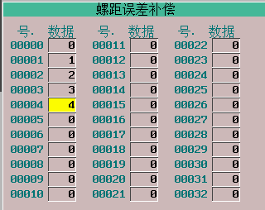
调试结果：
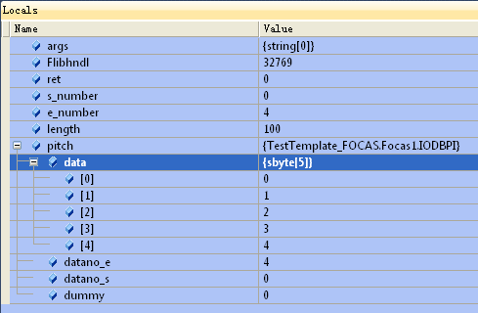
class Program
{
static void Main(string[] args)
{
ushort Flibhndl = 0;

short ret; // 返回值

// 获取库句柄 ( Ethernet )
ret = Focas1.cnc_allclibhndl3("192.168.0.224", 8193, 10, out Flibhndl);
if (ret != Focas1.EW_OK)
{
Console.WriteLine("发生异常，请检查！");
return;
}

#region cnc_rdpitchr

short s_number = 0;
short e_number = 4;
short length = 100;
Focas1.IODBPI pitch = new Focas1.IODBPI();
ret = Focas1.cnc_rdpitchr(Flibhndl, s_number, e_number, length, pitch);
#endregion
}
}

